30 | 2nd intermediate stage  Final exam, 2nd semester  Time / 1.5 hours |   1446  ثاني متوسط  الدور الأول | THE MINISTRY OF EDUCATION  ________ DIRECTORATE EDUCATIONAL  ________INTERMEDIATE SCHOOL
إسم الطالب :................................................................................ |  |  | رقم الجلوس: .......................
Student’s Mark Written /

Comprehension

Q1: Read the passage then answer the questions:

Jim’s house is nice and big. It has three bedrooms and two bathrooms upstairs. Downstairs there’s a living room, a dining room, and a kitchen. There’s a pretty garden in front of the house. Behind the house, there are trees.

6
- Put ( √ ) or ( X ):

• Jim’s house is nice and small. ( )
• There’s a pretty garden in front of the house. ( )

- Choose the right answer:

• Jim’s house has ( four - two - three ) bedrooms.
• Downstairs there’s a living room, a dining room, and. ( room – a kitchen – house ).

- Complete:
• Behind the ………………………………., there are ………………………………. .

Grammar

Q1: Choose the right answer:

7
- There ( am - are - is ) four people at the table.
- I ( live - living - lived ) in Jeddah.
- Are you ( studied - study - studying ) now.

Q2: Complete sentences with correct words:

very - because - on

- He’s taking a nap …………………………………. he’s tired.
- Ali is ……………………….…. tall.
- I get home at seven o’clock in the evening .…………… Sundays and Mondays.

Q3: Correct
- They works in a store. …………………………………………………………………………
1
Vocabulary

7
Q1: Write word under the right picture:
Airport - Garden - Housework - Laptop - Accident
 |  |  | 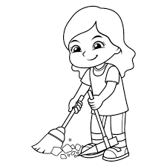
……………………..……..…….. | ……………………..……..…….. | ……………………..……..…….. | ……………………..……..……..

Q2: Write word’s number in left in front of suitable word in right :

1. Smart ( ) teaches at a school.
2. Teacher ( ) intelligent.

Q3 : Reorder :
Where - You - Live? – do ……………………..………………………………………………………………………..……..
Spelling

Q1: write the missing letters :

4

o - e - m - l - a

 | 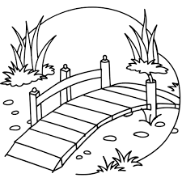 | • I’m a me ___ ber of the football club.  • Ben is the tall boy with b ___ ond hair and blue eyes.
• Cam___ ra. | • Pa ______ k. .

Composition

Q1: Write a paragraph about your dream house no less than 50 words, use the following words and phrases:

6

Big or small – bedrooms – Downstairs - upstairs - yard. - garden - trees

................................................................................................................................................................................................................................................
................................................................................................................................................................................................................................................
................................................................................................................................................................................................................................................
................................................................................................................................................................................................................................................
................................................................................................................................................................................................................................................
2

