المملكة العربية السعودية  وزارة التعليم  إدارة تعليم  مدرسة ابتدائية |  | المادة : لغة انجليزية  الصف : السادس الابتدائي  الزمن : ساعة و نص
اختبار النهائي الفصل الدراسي الثالث – ) الدور الأول ( – للعام الدراسي 1444هـ

س | المهارة | الدرجة | بالارقام | الدرجة بالاحرف | المصححه |  | المراجعه | المدققة
1 |  | 6
2 |  | 4
3 |  | 6
4 |  | 4
5 |  | 5
6 |  | 5
المجموع |  | 30
اسم الطالبة |  | ------------------------ |  |  | الفصل |  | رقم الجلوس
Q1. General Questions: Choose:
6

- Does your school have a school bus ? ---------
- I don’t have. B- About 1000. C- It has a big yellow bus.
- What time does your school start? ---------
A- No, it doesn’t. B- It has a big yellow bus. C- It starts at 7:00.
- What should you do to live a healthy life? I should-------.
- stay up late. B- watch too much TV. C- drink a lot of water.
- How much is it?---------
- Yes,I did . B- Yes, thanks C-It’s 30 SAR.
- Where are you going? ---------
A-I’m going to Dubai. B- Apple juice,please. C- We bring our own.
- Where is the post?--------
A- It’s near here. B- Do not litter. C- No, we don’t.

Q2. Reading: (Match)
4
Because
1-It made the children laugh. he ate a whole pizza .

2-He has a stomachache.. to see a lamb at school.
3- We‘re going to the bookstore it’s so cute
4-Why did you take my panda? we want some books.

Q3. Vocabulary:
A-Match the numbers with the pictures:
6
6-  no ball | 5-  Flowerstore | 4-  toothache | 3-  no bicycles | 2-  earache | 1-  DVD store
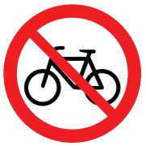
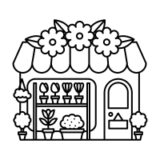
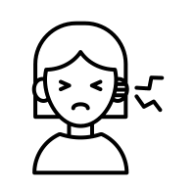
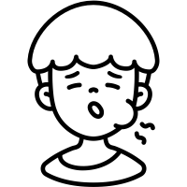
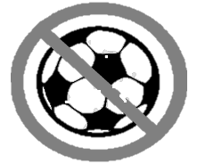

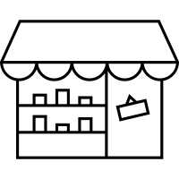

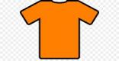
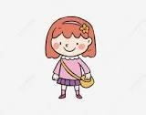
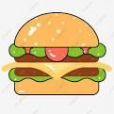
B-Circle the correct word :
wealthy | Bakery | school | Turn left | grumpy | PE
poor | Book store | mosque | Turn right | wise | Maths

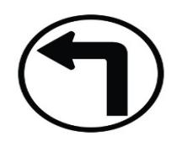

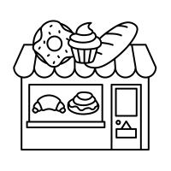

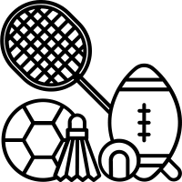


Q4. Orthography A-Complete the missing letter:
4
(ir _sq _ ar _ sk _ ur _ sc _ u-e_ ue )
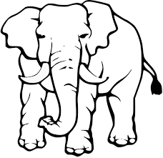
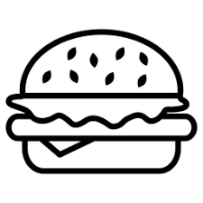
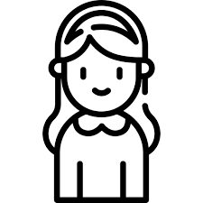

P _ _k | h _g _ | B_ _ger | G _ _l
 |  | 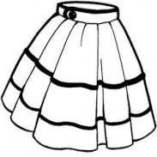 |   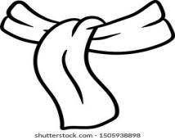  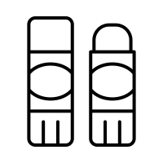  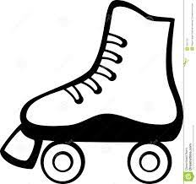
gl_ _ | _ _ate | _ _arf | _ _uare

B-Choose the right spelling
_ _ueezing |  |  | 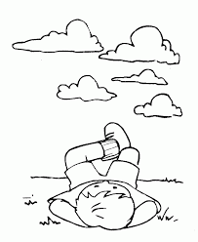  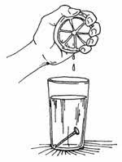 | Sh_ _t |  |  | 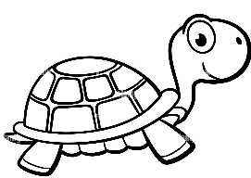  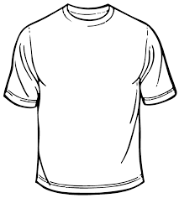
Sq | Sc | Sk |  | ur | ir | or
_ _y |  |  |  | t_ _tle
Sq | Sc | Sk |  | ur | ir | or
C-Unscramble the letters and write
tsrki | 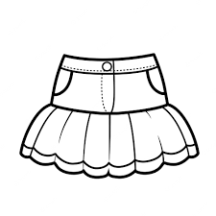  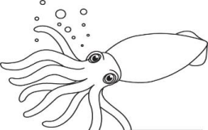 | uecb. |   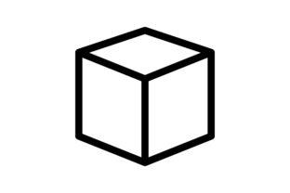
sdqui |  | stuesi.

Fill in the missing letter:
Fill in the missing letter:
.

Q5. Writing :
5
A-(Rearrange)>
- you? - I – Can –help _____ _____ ______ ______
- had-Rana - lamb. -a little _____ _____ ______ ______
- bakery. _ to _ the_going_She's ____ ____ _____ ___ ___
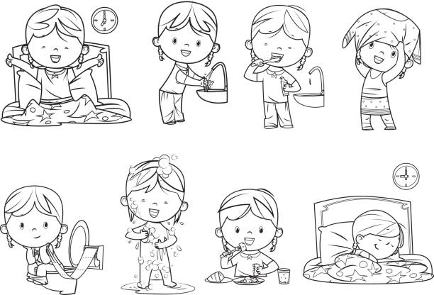
B-(Complete)> ( go - take - eat )
1- I ____________ my breakfast.
2-I ____________ to bed early.

5

Q6. Grammar:
1-This year I (like –likes– liked) Math..
2- I should (eats – eat– ate) three meals a day.
3-Did you (brush - brushed - brushes ) your teeth ?
4- There (be – was – were ) two floors.
5- I (is – are – am ) going to the stationery store.
6-Last year we (goes – go – went) to Riyadh.
7-This year I (be – am – was) in the 6th grade.
8- She (is – are – am ) going to shop in Dubai.
9-He‘s going (to visit -visit - visited)the Children‘s Art Show .
10-( Does– Do – Did ) you get up early this morning?
Good luck

المملكة العربية السعودية  وزارة التعليم  الإدارة العامة للتعليم بـن  مدرسة مستقبل ن الابتدائية |   بسم الله الرحمن الرحيم  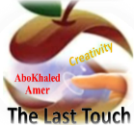  اختبار الفصل الدراسي الثالث  للعام الدراسي 1444 هـ | المادة | لغة انجليزية
 |  | الصف | السادس
 |  | الزمن | ساعة ونصف
 |  | الفصل | ----- /6
اسم الطالب رباعيا: .............................................................................................................
السؤال | 1 | 2 | 3 | 4 | 5 | 6 | المجموع
الدرجة
الدرجة | 4 | 5 | 6 | 6 | 5 | 4 | 30
المصحح

match: General Questions

4
1. How many students are there in your school? ------------------------------------.
2. What would you like to drink? ------------------------------------.
3. What time does your school start? ------------------------------------.
4. Can I help you? ------------------------------------.
match: Controlled Writing

5
1. This year, I am in the 6th _______. a. much
2. Speak ____in class. b. grade
3. How ____is it? It's 160 SR. c. English
Rearrange:
1. Riyadh – in – I – live -------------------------------.
2. going – I'm – to – store – candy - the ---------------------------.
Choose: Grammar

6
1.Last year, I (is – was – am) in the 5th grade.
2. This year, I (like – liked - likes) English.
3. The past of "drink" is (drank – drinking – drinks).
4. The past of "get up" is (get up – got up – gets up).
5. I (is – are – am) going to the doctor.
6. (There is – There are – Is there) two floors.
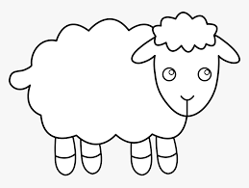
match: Vocabulary

6
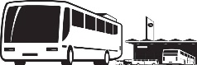
math
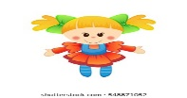
sky diving

lamb
globe
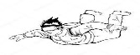

bus stop
doll

5


match: Reading

1. I have an earache.
2. I want a sweater.
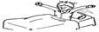
3. I should get up early.

4. Don't make too much noise.
5. I have a headache.
match: Orthography

4
1. _ _ arf u-e
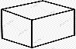
2. c _ b _ ir
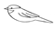
3. b _ _ d sq
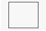
4. _ _ uare sc

End of Questions
المملكة العربية السعودية  وزارة التعليم  الإدارة العامة للتعليم بـن  مدرسة مستقبل ن الابتدائية | بسم الله الرحمن الرحيم  اختبار الفصل الدراسي الثالث  للعام الدراسي 1444 هـ | المادة | لغة انجليزية
 |  | الصف | السادس
 |  | الزمن | ساعة ونصف
 |  | الفصل | ----- /6
اسم الطالب رباعيا: .............................................................................................................
السؤال | 1 | 2 | 3 | 4 | 5 | 6 | المجموع  30
الدرجة
الدرجة | 6 | 4 | 5 | 6 | 4 | 5 | 30
المصحح



Q1 A. Choose the suitable answer:

6
1: What's the name of your school?

Future ( Hospital – School – Market ).
2: What should you do to be healthy?
I should get up ( early – late – Najran ).
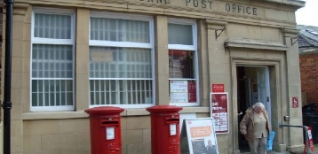
3: Excuse me. Where's the post office?
It's ( seven o'clock – a shop – near here ).
B. Answer
1- How many students are there in your school? ………………………………..
2- Did you get up early this morning? …………………………………..…….
3- Why are you going to the bookstore? …………………………..

4
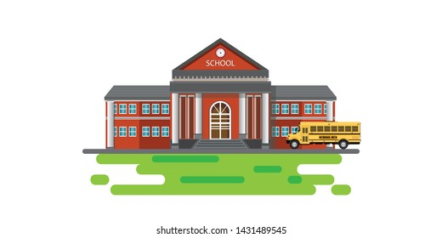
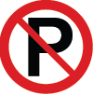
Q2 A. Match the sentence with a picture:
1. There was a little green house. ( )
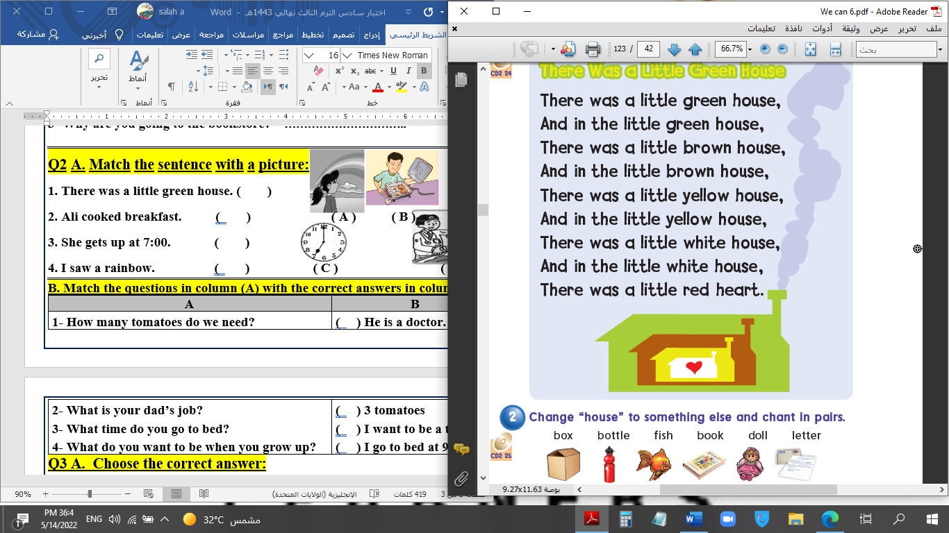
2. Don't park your car here. ( ) ( A ) ( B )
3. I'm going sightseeing. ( )
4. My school is cool. ( ) ( C ) ( D )
B. Match the questions in column (A) with the correct answers in column (B):
B | A
( ) I shouldn't skip meals.  ( ) No, we don't.  ( ) Yes, please. I want a pen.  ( ) I liked PE and Art. | 1- Do you have a school uniform?  2- Which subject did you like most last year?  3- What shouldn't you do to be healthy?  4- Can I help you?
Q3 A. Choose the correct answer:

5
1. She is (go – goes – going) to the stationery store.
2. (Who – What – How) long does it take to get there?
3- Don't shout; speak (clearly – clean – clear).
B. Put in the verb column: had / make / went / follow
past | present
/ | /
Q4: A. Write the correct number under each picture:

6
1- burger 2- shirt 3- glue 4- skirt 5- scarf 6- globe
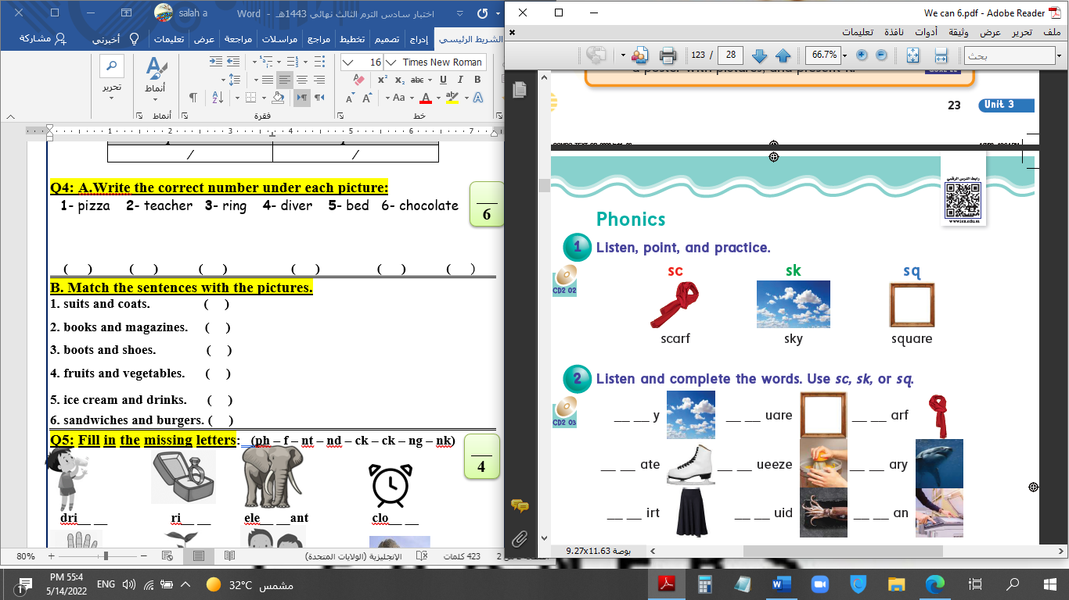

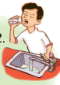
( ) ( ) ( ) ( ) ( ) ( )
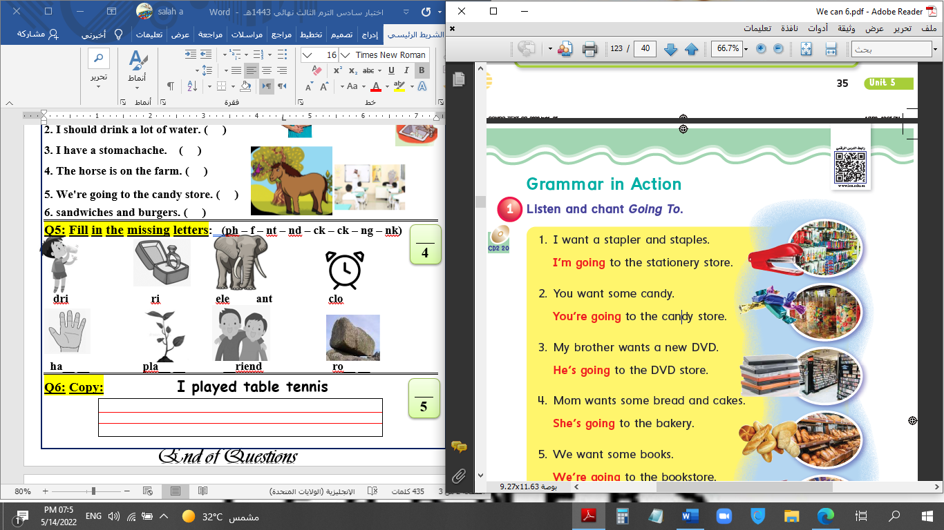
B. Match the sentences with the pictures.
1
1. Listen to the teacher. ( )
3
2
2. I should drink a lot of water. ( )
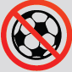
3. I have a stomachache. ( )
6
5
4. The horse is on the farm. ( )
4
5. We're going to the candy store. ( )
6. No balls. ( )
Q5: Fill in the missing letters: (sq /qu /sk /sc /ue /u-e /ir /ur)

4

_ _y g _ _ l barbec_ _ c_t_

t_ _ tle _ _ary mos_ _e _ _ueeze
Q6: Copy: What would you like to eat ?

5
End of Questions




وزارة التعليم
الإدارة العامة للتعليم بمنطقة ........
مكتب ............
مدرسة .....................
التاريخ : / / 1444هـ
الصف: السادس الابتدائي
المادة : اللغة الإنجليزية

اختبار اللغة الإنجليزية نهائي – الدور الأول – للصف السادس – الفصل الدراسي الثالث 1444ه
اسم الطالب: ..................................................... الفصل: .........
6
I- General Questions:
A- Match the questions in column (A) with the correct answers in column (B):
B | A
( ) I'm going to Jeddah.  ( ) Yes, I got up early this morning.  ( ) I'm going diving.  ( ) I should drink a lot of water.  ( ) I have a headache .  ( ) Go straight and you'll find it. | 1- Did you get up early this morning?  2- What's the matter?  3- Where are you going at weekend?  4- Where's the post office?  5- What are you going to do there?  6- What should you do to live in a healthy life?

II- Controlled Writing:
5
A- Complete the sentences with the correct word:
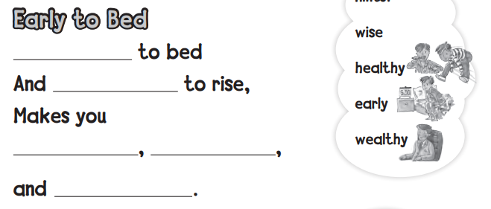

4
III- Reading Short Sentence:
A- Read the sentences and match them with the correct pictures:

1- I should brush my teeth. 2- No bicycles 3- I have an earache 4- I shouldn't eat junk food.


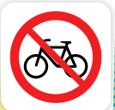
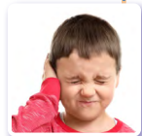

IV- Grammar:
5
A) Choose the correct word:
1- Yesterday, I ( play - played ) computer games.
2- He ( am - is ) going to the book store.
3- We are going to ( visit - visited ) Abha.
4- You should ( drink - drank ) milk.
5- What are ( she - they ) doing?

6
V- Vocabulary:

A) Write the correct number under each picture:
1- butcher shop 2- shower 3- stomachache 4- burger 5- candy store 6- flower store



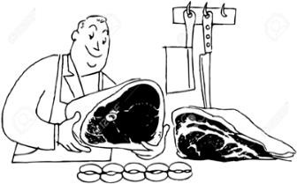
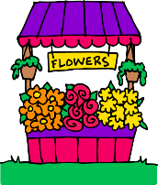
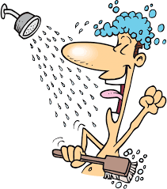
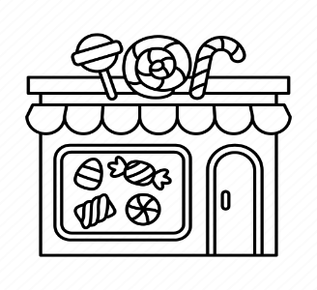

( ) ( ) ( ) ( ) ( ) ( )

VI- Orthography:
4
A) Choose the correct letter:
ir u e tl ur

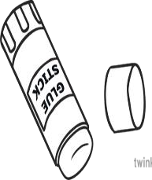
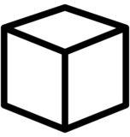
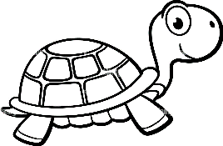
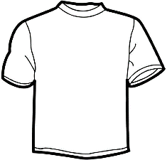

4- sh_ _ t 1- t _ _ tle 2- c _ b _ 3- gl _ _

