Name: ................................... Ms. Tahani
Class: 5th + 6th Elementary / ........
Revision Sheet _ Unit (6): Outdoor Activities
- General Questions:
  - Match the questions with the correct answers:
A | B
1. What activities do you do outside? |  | I prefer activities I do outdoors.
2. Do you prefer activities you do outdoors or at home? |  | We should wear the right equipment.
3. What items do you need for fishing? |  | Go climbing in the mountains.
4. What do you know about being safe outdoors? |  | I need fishing rod for fishing.
  - Choose the correct answer:
1- Which activities can make you tired, scared, or bored?
a- playing video games. | b- hiking in the forest.
2- Did you have fun on your trip?
a- Yes, I was. | b- Yes, I did.
3- What items do you need for camping?
a- a tent and a sleeping bag. | b- a surfboard.
4- Name two landscapes.
a- canoeing and rafting. | b- cliffs and deserts
- Guided Composition:
  - Use the following word bank to write a blog post about Outdoor Safety.
wear equipment listen follow careful fun
___________________________
________________________________________________________________________________________________________________________________________________________________________________________________________________________________

  - Use the following word bank to write a paragraph about Your Last Outdoor Activity.
___________________________
________________________________________________________________________________________________________________________________________________________________________________________________________________________________

camping tent flashlight cooked took felt

- Reading Short Sentences:
  - Read the sentences then match them with the correct pictures:
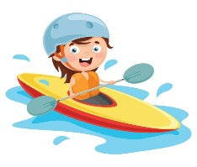 | 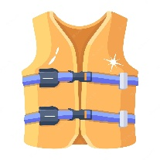 | 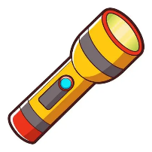 | 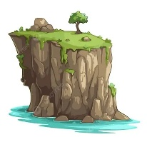
a-_I go surfing on the waves.  b-_I go canoeing on the lake. | a- It is a life jacket.  b- It is a backpack. | a- It is a flashlight.  b- It is a raft. | a-_That is a cliff.  b-_That is a forest.

  - Read the passage and answer the questions below.
Camping
Camping is a fun outdoor activity that families can do together. When you go camping, you get to sleep in a tent and spend time in nature. You might go hiking, swimming, or have a picnic. To go camping, you will need a tent, sleeping bags, and a flashlight. You should also bring food, water, and clothes for different weather. it is important to be safe when you are camping. Stay with your family and follow the rules of the campground. Have fun and enjoy the fresh air and beautiful scenery!
- Choose the correct answer:
1.Where do you sleep when you go camping?  a- on the bed  b- on the sofa  c- in a tent | 2. What do you need to bring when you go camping?  a- surfboard  b- sleeping bags & a tent  c- toys
3. What are some things you can do when you go camping?  a- hiking  b- surfing  c- watching TV | 4. How can you stay safe when you are camping?  a- follow the rules of the campground.  b- don’t listen to the adults.  c- don’t follow the rules.

- Grammar:
  - Choose the correct answer:
    - He was (sleep – slept – sleeping) in a tent for four days.
    - She (learn – learned – learning) how to climb yesterday.
    - They didn’t (see – saw – seeing) the snake.
    - We were canoeing (when – while) it started raining.
    - (When – While) Jack was rafting, his raft hit a rock.
    - She was taking photos when you (go – went – going) to your tent.
    - We ate hot dogs while we (sit – sits – were sitting) around the campfire.

  - Do as shown between brackets:
    - He saw a bear.
- …………………………….. (Make it negative)
- …………………………….. (Make a Yes/No question)

- Vocabulary:
  - Write the words under the correct pictures:
fishing rod – horseback riding – mountain biking – forest – rope – river – thirsty – climbing
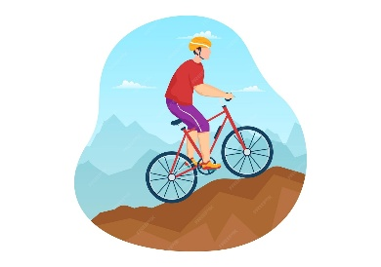
 | 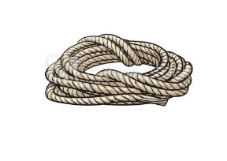 | 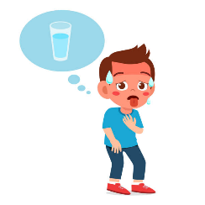 | 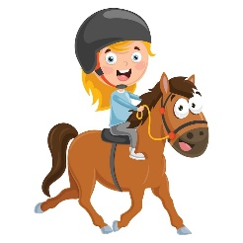
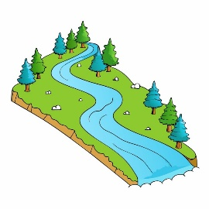 | 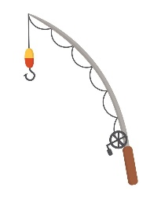 | 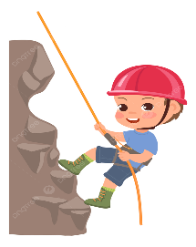 | 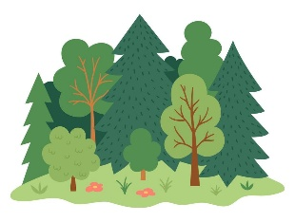

  - Fill in the blanks with the words from the box.
climbing – camping – fishing – hiking
1- An activity that involves sitting still and waiting. (………………….)
2- An activity that involves sleeping outdoors. (………………….)
3- An activity that involves long walks. (………………….)
4- An activity that you do on rocks or mountains. (………………….)

  - Circle the odd word:
- Outdoor activities: sleeping bag – hiking – rafting – climbing
- Items: canoes – tent – bear – helmet
- Landscapes: forest – cliff – equipment – desert

  - Read the words in bold then choose noun or adjective:
1- Mom, where are my hiking boots? | a. noun | b. adjective
2- My family and I love camping. | a. noun | b. adjective
3- We need to buy a new sleeping bag. | a. noun | b. adjective
4- Mom always says she wants to go canoeing. | a. noun | b. adjective

- Orthography:
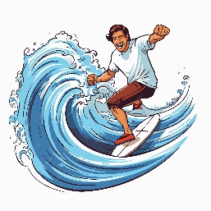
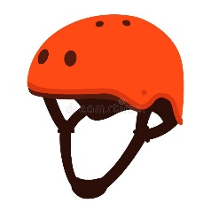
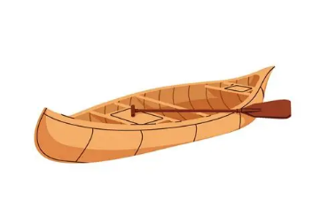
  - Choose the correct missing letters:
ca__oe |  | h__lmet |  | 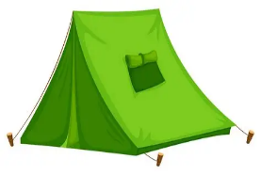  ten__ |  | su__fing |  | 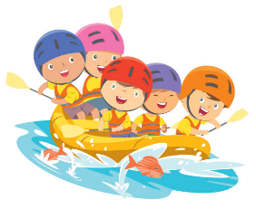  ra__ting
m | n | i | e | t | b | r | v | f | v
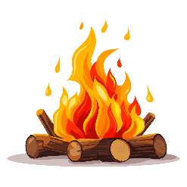  cam__fire |  | 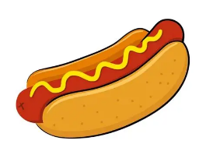  hot d__g |  | 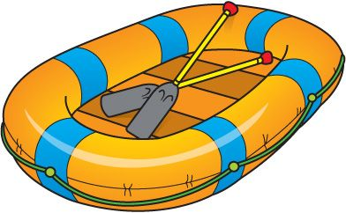  r__ft |  | 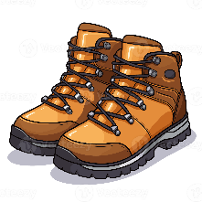  hi__ing boots |  | 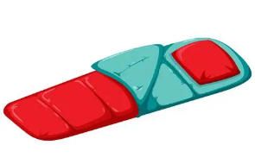  slee__ing bag
q | p | o | u | e | a | k | x | b | p
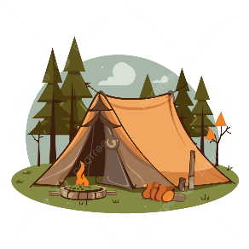  camp__ng |  |   s__rfboard |  | 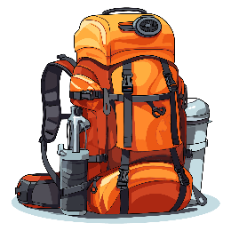  back__ack |  | flash__ight |  | 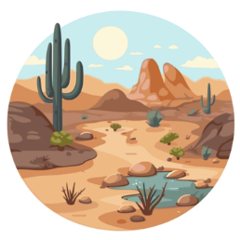  de__ert
i | y | u | o | b | p | l | h | z | s

BEST OF LUCK

