المملكة العربية السعودية  وزارة التعليم  الإدارة العامة للتعليم بـن  مدرسة مستقبل ن الابتدائية | بسم الله الرحمن الرحيم    اختبار الفصل الدراسي الثالث  للعام الدراسي 1444 هـ | المادة | لغة انجليزية
 |  | الصف | الرابع
 |  | الزمن | ساعة ونصف
 |  | الفصل | ----- /4
اسم الطالب رباعيا: .............................................................................................................
السؤال | 1 | 2 | 3 | 4 | 5 | 6 | المجموع
الدرجة
الدرجة | 6 | 6 | 4 | 5 | 4 | 5 | 30
المصحح


I- General Questions:

6
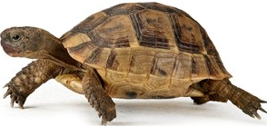
Q1: A- Choose the correct answer:
1. Do you have a pet?
( Yes, I am 9 years old – Yes, I have a turtle - Yes, I am fine )

2. What day do you like?
I like ( Ali – windy - Friday ).
3. What's the weather like today?
It's ( sunny - Monday - cow ).

B- Match the questions in column (A) with the correct answers in column (B):

6

6
B | A
( ) I'm thirsty.  ( ) Yes, I am.  ( ) These are shirts. | 1. Are you happy? 2. What's the matter? 3. What are these?

Q2: A Write the correct number under each picture:
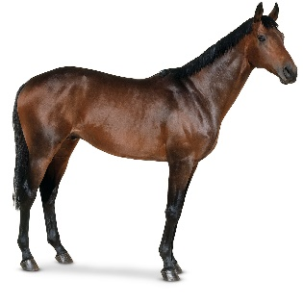
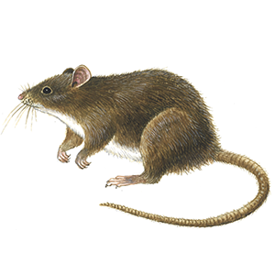
1.zebra 2.mouse 3.umbrella 4.horse 5.rainy 6.hungry


( ) ( ) ( ) ( ) ( ) ( )

Q3: Put ( ) or ( X ):

4
1. I have a fish. ( )
2. It is a tiger. ( )

3.There was a farmer who had a horse. ( )
4. It is windy today. ( )

Q4: A. Choose the correct answer:

5
- ( Do – Is – Are ) you have a pet?
- I ( likes – like - liking ) Sunday.
- ( He – She - We ) is scared.
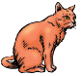
- B – Change into plural
One duck | twelve ----------
One cat | ten ----------

4
Q5: Choose the missing letter:
__ase | __olf | __loudy | __aptop
F – V | W - F | C - K | L - C

Q6: Copy:

5
I have a new cap.

End of Questions


التاريخ: / / 1444هـ
الصف: الرابع الابتدائي
المادة: اللغة الإنجليزية


وزارة التعليم
الإدارة العامة للتعليم بمنطقة ................
مكتب ...............
مدرسة ....................................

اختبار اللغة الإنجليزية نهائي – الدور الأول – للصف الرابع – الفصل الدراسي الثالث 1444هـ
اسم الطالب:........................................................ الفصل:.............
I- General Questions:
A- Answer the following questions correctly:
6

1- What time is it?
A – It's seven o'clock. B – It's fife o'clock.
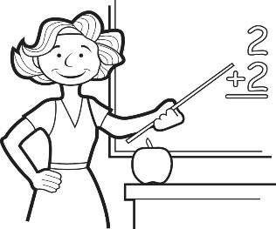
2- Is she a doctor?
A – Yes, she is. B – No, she isn't.

B- Match the questions in column (A) with the correct answers in column (B):
B | A
( ) I get up at 6 o'clock.  ( ) He's a teacher.  ( ) They are 7 days.  ( ) Sure. Here you go. | 1- How many days in the week?  2- Can I use your pen?  3- What does he work?  4- What time do you get up?
II- Controlled Writing:
summer
sunny
fly

5
A- Complete the sentences with the correct word:
1- Ostriches can run but they can't ………………
2- It's ………………………… and very hot in ……………………

B- Rearrange the words to form a sentence:

1- is / a / . / He / pilot
………………………………………………………………………………………………………………………….
2- is / a / This / . / watch
………………………………………………………………………………………………………………………….

III- Reading Short Sentence:
4
A- Read the sentences and match them with the correct pictures:

1- They are wallets. 2- It's a sheep. 3- It's snowy and cold. 4- They're cooks.



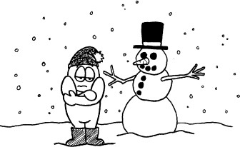
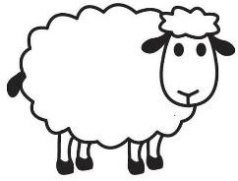

IV- Grammar:
5

A) Choose the correct word:
1- They ( is – are ) pencils.

2- What ( do – does ) she do?

3- ( That – These ) is my eraser.
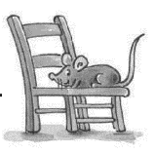
4- What are ( this – these )?
5- The mouse is ( under – on ) the chair.
V- Vocabulary:
6
A) Write the correct number under each picture:
1- candy 2- watch 3- MP3 player 4- kangaroo 5- scissors 6- firefighter






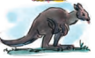

( ) ( ) ( ) ( ) ( ) ( )
VI- Orthography:
4
ea - sp - sm - sw

A) Choose the correct letter:

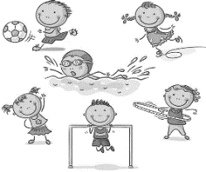



1- _ _ an 2- h _ _ d 3- _ _ ort 4-_ _ ile
المادة: اللغة الانجليزية
الزمن : ساعة ونصف
المدرسة:
مدرسة : .....................

اختبار مادة اللغة الانجليزية للصف الرابع الفصل الدراسي الثالث الدور الأول لعام1444

المملكة العربية السعودية
إدارة تعليم الطائف

30
الاسم : ......................................................

ك

/

Q1. General Questions :

A)- Match:
1-What is the weather like?

2- Would you like to come in?

3- What time is it?

3

7
A- 35 _____37______ 39______41______43

B- 50 ______ 70 _______ 80 _______

Q3. Complete numbers :

اقلب الصفحه
It's 7:00 o'clock. please
m / ee / ea / o / h

5
Q2. Controlled Writing :
A)- Complete with words from the box:

1-gr _ _ n. 2- s_all . 3- h_ _ d
4- ro_m 5-fis_
Yes, please.

It's rainy.

These | This | 1 – ……… are wallets.
are | is | 2- These ……… books.
Q6. Writing :
A)- Copy 4 times :
I am playing football and tennis.

C)- Read and write the suitable word :

.............../................../.................../.................../ .................. /....................

6
Q5. Vocabulary:

Q4. Grammar:
A)- Complete :
{ behind / on/ next to }
1-The elephant is………………………….. the board .
2- The mouse is …………………………the chair.
3-The cat is ………………………………..the box.
B)- Choose the correct answer :

.

5

4
انتهت الأسئلة
Good Luck

bedroom / door / watch / sunny / scissors / doctor

