  وزارة التعليم  الإدارة العامة للتعليم بمنطقة ...................  مدرسة .............................. |  |    | السؤال | الدرجة |  | اسم المصحح وتوقيعه | اسم المراجع وتوقيعه
 |  |  | السؤال | رقما | كتابة | اسم المصحح وتوقيعه | اسم المراجع وتوقيعه
 |  | الاختبار النهائي للفصل الدراسي الاول  ( الدور الأول )  للعام الدراسي      1447 هـ | الأول
 |  |  | الثاني
التاريخ | / / 1447 هـ |  | الثالث
المادة | اللغة الانجليزية |  | الرابع
الزمن | ساعة ونصف |  | الخامس
الصف | الرابع |  | المجموع
اسم الطالب : ............................................................................................. |  |  |  | رقم الجلوس : ............................
- General Questions:

7

- Choose the correct answer:
- What is your favorite story? A - I like to jump a rope B- Cinderella
- How was your day at school yesterday? A - It was great B - I played soccer
- What time do you get up in the morning? A - At 6 o’clock B - Yes, she did
4 - Whose dress is this? A - I usually do it on weekend B - It is mine
5 - Can I help you with your homework? A - Yes, please! B - No, I couldn’t
6 - What are you doing now? A - I am watching TV B - It was boring
7 - How many brothers do you have? A - No, I didn’t. B - I have 3 brothers

- Controlled Writing:
takes out – feed – sweep – wash – clears
- Fill in the missing words:
My brother and I help our grandparents on Saturdays. I usually (1)……………... the floor. Then, I (2)……………... the animals. My brother (3)……………... the trash. My brother always (4)……………... the table after we eat and then I (5)……………... the dishes for my grandma.

- Rearrange the words to form a sentence:

7

    - took photos – zoo – at the – She
………………………………….…………………………………..
    - he – the movie? – like – Did
…………………………………………………………………..
- Reading Short Sentence:
- Read the sentences then choose the correct sentence for each picture:
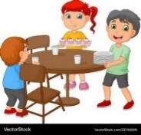 |  |  |   7
a-_They set the table.  b-_They cut the grass. | a-_I fix the hose.  b-_I water the plants. | a-_I play video games.  b-_I play board games. | a-_She is shy.  b-_She is lazy.

B-Read the sentences and match them with the correct pictures:
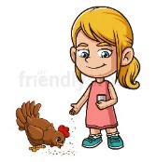


1– She feeds the chickens 2– I always read comic books 3– They catch the bus.

- Grammar: A – Choose the correct answer:

7

- She (didn’t see – didn’t saw) a movie.
- They (play – are playing) football every day.
- How often ( does / do ) you help your family?
- Did you (take – took) photos in the park?
- She (always sleeps – sleeps always) early.
- ( Does – Did ) he send an e-mail last week?
- I like soccer, (and – but) I don’t like tennis.

7

- Vocabulary:
- Choose the correct answer:
1 – present 2 – helpful 3 – fix 4 – piano 5 – cry 6 – wash the dishes 7 – graduation

 |  |  |  | 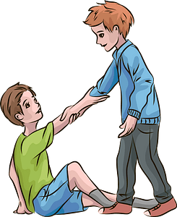 |  | 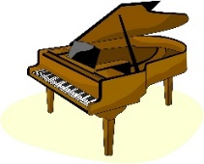


5

- Orthography:
- Choose the correct missing letters:
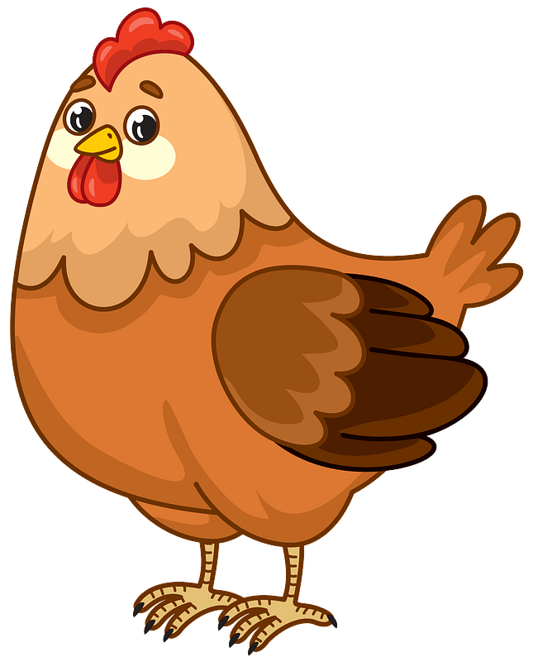  chicke__ |  |   te__ting |  |   mu__ic |  | 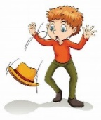  dr__p |  | 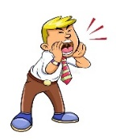  shou__
m | n | x | k | s | k | o | u | e | t

