Name:
VOCABULARY
- Look, read, and complete with the words in the box. / 5 points
asleep fast frightened parrot slowly
 1 The boy is .

 2 The polar bear is .

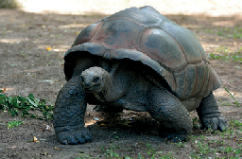 3 The tortoise is moving .

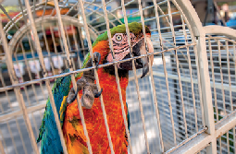 4 The is in a cage.

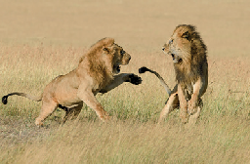 5 The lions are moving .

- Read and circle the correct option. / 5 points

- My cat is very pretty / friendly. He loves playing with children.
- Parrots are smart / careful—they can talk to people!
- It’s not pretty / safe to stand close to a lion. They’re dangerous.
- Giraffes are tall / smart. They have long necks and legs.
- Snails can’t move quickly. They are slow / brave.

GRAMMAR
- Read and circle the correct option. / 5 points

- Australia is the country where / who kangaroos live.
- Bingo is the animal that / whose has a long tail.
- Saturday is the day which / when we go shopping.
- Faris is the boy who / whose helped me with my homework.
- The book that / who I want to buy is very old.

- Complete with a comparative or superlative form of the word in parentheses. / 5 points

- A tortoise is than a cat. (slow)
- Do you think the parrot is the animal? (intelligent)
- Rabbits are than tigers. (friendly)
- I think cats are the animals. (cute)
- A giraffe is than a parrot. (tall)

VOCABULARY AND GRAMMAR
- Read and circle the correct option. / 10 points
Yesterday, we went to the zoo with our teacher. We saw lots of animals! The lions are dangerous, so we had to be (1) careful / friendly around them. They are in a (2) cage / jungle and it’s not (3) safe / pretty to stand too close to them. We saw a tortoise in the water. It was moving (4) slow / slowly. The (5) most beautiful / more beautiful animals we saw were the polar bears. I loved them! We saw pandas, too. Our teacher doesn’t like pandas. Her favorite animal is the parrot. Parrots are very smart—they are (6) more
/ most intelligent than pandas. We saw a parrot (7) whose / that talked to us! In the afternoon, we talked to Mr. Saeed. He is the vet (8) which / who looks after the animals. He is very (9) brave / frightened: he opened the door and went into the cage (10) where / when lions live!

TOTAL / 30 points

