Name:
VOCABULARY
- Look and circle the correct option. / 5 points
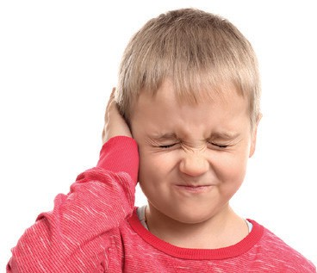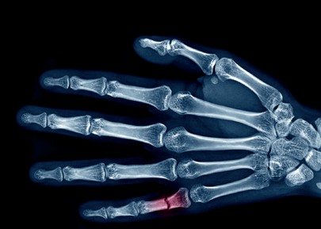

- earache / toothache
- cough / cry
- back / X-ray

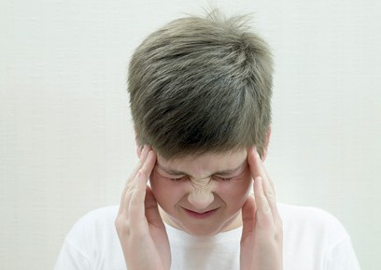
- fall / sick 5 headache / stomachache

- Read and complete with the words in the box. / 5 points
all right band aid downstairs ill put on
- Yesterday, I was sad and tired. But today, I’m !
- I have a bad cut. I need a .
- When you ride your bike, your helmet.
- You look . I think you should see a doctor.
- I hurt my arm when I fell .

GRAMMAR
- Read and circle the correct option. / 5 points
- Do you have a toothache? You should / don’t have to go to the dentist.
- You mustn’t / have to shout in the classroom.
- You mustn’t / must wash your hands before you eat.
- You don’t have to / must eat pizza if you don’t like it.
- You should / shouldn’t look at screens when you have a headache.

- Complete the sentences with the correct form of any-, every-, no-, or some-. / 5 points

- It’s very dark here. I can’t see .
- We all worked very hard yesterday, so is very tired today.
- There’s in my eye. I can’t see!
- Your back is OK. There’s wrong with it.
- My head, my leg, my arm, and my back hurts. It hurts !

VOCABULARY AND GRAMMAR
- Look, read and complete with the words in the box. / 10 points
anybody back band aid cut everywhere fall mustn’t right should X-ray
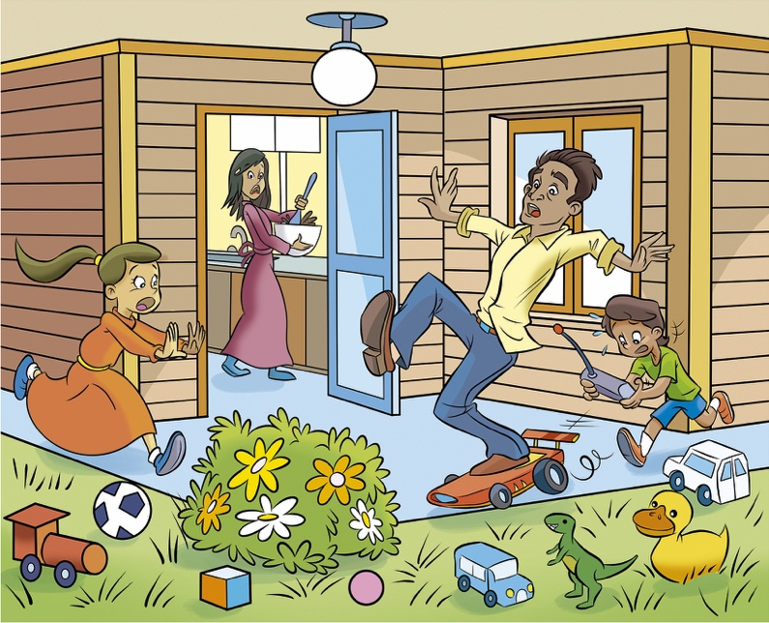
Alex and Lisa were playing in the yard when dad got home. Their toys were (1) . “Dad, be careful!” cried Alex. “You (2) step on the car!” But it was too late.
Dad fell into the flowers. “Ow! That was a bad (3) ,” said Dad. “Are you all
(4) , Dad?” asked Alex. “No. I hurt my (5) . I must go to the hospital and get an (6) ,” said Dad. “Here, Dad. You (7) put ice on your back”, said Lisa. “Thanks”, said Dad. “And I think I (8) my knee, too. I need a (9) . Does (10) have one?” “Yes, here you are”, said Mom.
TOTAL / 30 points

