Name:
VOCABULARY
- Look and write the words in the box. / 5 points
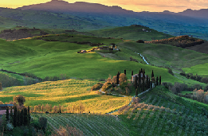
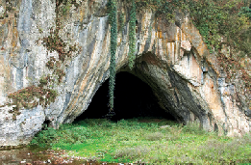
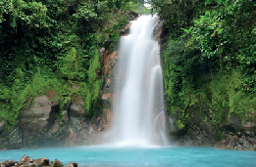
cave countryside Earth forest waterfall

1 2 3
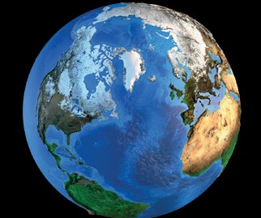
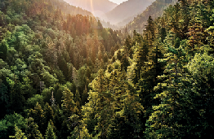

4 5

- Look, read, and circle the correct option. / 5 points
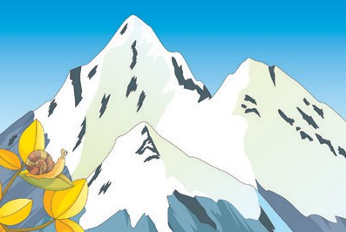 1 This is a high / low mountain.
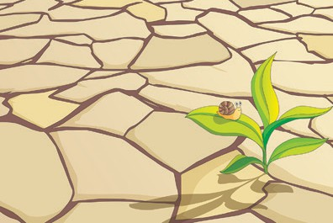 2 This ground / forest is very dry.
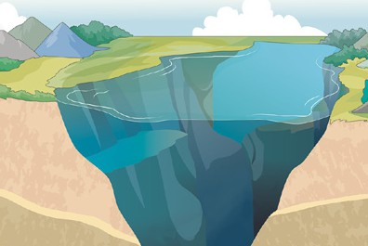 3 This is a high / deep lake.
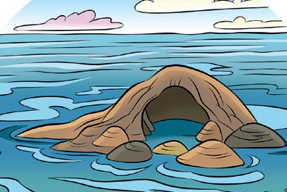 4 The island is close / far from the land.
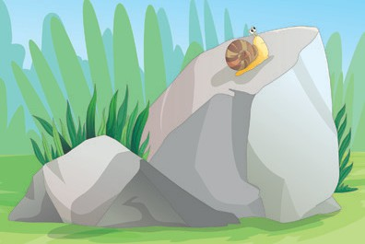 5 This is a hard / deep rock.

GRAMMAR
- Read and circle the correct option. / 5 points

- Sabah forgot to bring / bringing her lunch.
- Khalid didn’t want to go / going to the countryside.
- I love to ride / riding my bike to school.
- I wanted playing / to play outside, but it was very hot.
- We went walking / to walk in the park on Saturday.

- Read and complete with the correct form of could. / 5 points Amal: Rana, (1) you read when you were four?
Rana: No, I (2) .
Amal: And (3) you run when you were five?
Rana: Yes, I (4) run very fast, but I (5) swim.
I was afraid of water!

VOCABULARY AND GRAMMAR
- Read and complete the blog with the words in the box. / 10 points
climbing could couldn’t countryside forgot lake started to to eat want wanted

Hi! I’m Ashraf. I had a great vacation in the (1) . It’s my favorite place! The weather was good, so we (2) walk in the fields and swim in the
(3) . But one day, it (4) get very hot,
so we (5) stay outside. Then we played board games inside. There was also a forest. I (6) to climb the trees, but my brother hates (7) .
He’s afraid of heights! On another day, we wanted (8) next to a cave, but we
(9) to take our lunch! It was a great vacation. We really (10) to go back next year!

TOTAL / 30 points

