1st term الفصل الأول
Name : ………………………………………………….………………………………
الاسم: ………………………………………………….………………………………..
الصف: ………………………………………………….………………………………

Units :1-2-3

for We Can 2

General Revision

General Questions
A. Match "A" with "B":
"A" |  | "B"
1.How are you ? |  |  | Nice to meet you, too.
2.What's the matter ? |  |  | I'm fine, thank you.
3.Nice to meet you |  |  | I'm wearing a skirt and a blouse.
4.What is he doing? |  |  | I'm scared.
5.What are you wearing? |  |  | It is mine.
6.Whose hat is this? |  |  | He is playing football.
 |  |  | I'm first.
B. Choose the correct answer:
1-Wow! I like your jacket.
A. Thank you. B. Nice to meet you. C. It is mine.
2-Whose hat is this?
A. Hello. B. It’s mine. C. Thank you.
3-It is nice to meet you.
A. Nice to meet you, too. B. You are welcome. C. No
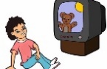
4-What is he doing?
A. They are sad. B. He is watching TV. C. I'm hungry.
5-How are you?
A. I'm great, thanks. B. It's not mine. C. Hi

C-Answer the following questions :
1.How are you? ……………………………………………………………….
2.Nice to meet you . ……………………………………………………………….
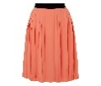
3.What is this? ………………………………………………….
3.What are you doing? ………………………………………………….
Controlling Writing
A. Reorder to make a correct sentence:
am-waching -.- TV-I
…………………………………………………………………………………………………………………………………
...............................................................................................................................................
wearing- is –a –She-. – hat
…………………………………………………………………………………………………………………………………
...............................................................................................................................................
B. Reorder to make a correct Question:
the- is -? – matter- What
…………………………………………………………………………………………………………………………………
...............................................................................................................................................
you- What-doing-?- are
…………………………………………………………………………………………………………………………………
...............................................................................................................................................
Reading Short Sentences:
He is hungry.

He is thirsty.

She is sleepy.

She is scared

They are sad.
A. Choose the right picture:
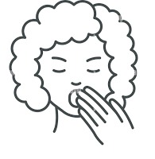
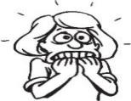

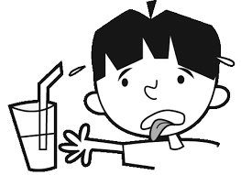
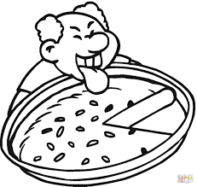

B.Choose √ or ×
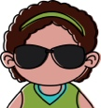  1.She is wearing sunglasses. | √ ×
  2.He is wearing a jacket. | √ ×
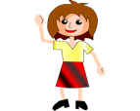  3.She is wearing a skirt. | √ ×

Grammar
A.Choose the correct answer:
1-I………wearing a dress.
A. are B. am C. is
2- ………… hat is this?
A.Whose B. What C. When
3-It is …………
A. mine B. he C. my
4.He ……… doing his homework.
A. are B. am C. is
5. They are ………… football.
A. play B. playing C. plays
6.What ………… the matter?
A. are B. am C. is
7. It is …… skirt.
A. an B. a C. -
8. We …… wearing green.
A. are B. am C. is
9. What are you ………… ?
A. do B. doing C. does
10. She …… cold.
A. are B. am C. is
B. Correct the mistakes between brackets:
1. ( Who ) is the matter ? …………………………………..…………………………….
2. He ( am) watching TV. ……………………..…………………………………….
3.(What) is wearing green today ? ……………………………………………..
4. What are you ( do )? ……………………………………………………….………..…….
5.(Who) hat is this? It's mine. ……………………………………………………………..…….

Vocabulary
A.Tick (✔) the correct answer:
B.Write the correct words under each picture :
doing Karate –eating snacks - playing football- doing homework- watching TV
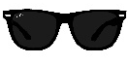 | 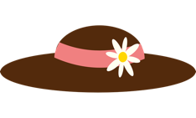 | 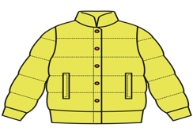 | 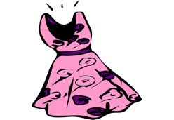
They're sunglasses.( ) | It’s a t-shirt.( ) | It’s a jacket.( ) | It’s a hat. ( )
It’s a hat. ( ) | It’s a hat. ( ) | It’s a cap. ( ) | It’s a dress.( )
It’s a skirt ( ) | It’s a blouse. ( ) | It’s a dress. ( ) | It’s a cap. ( )

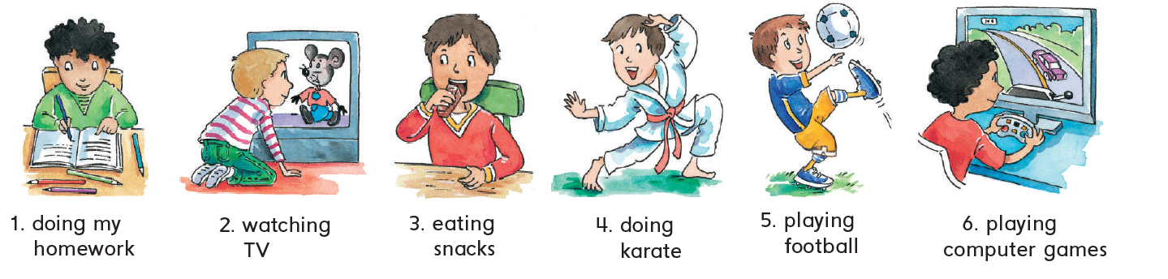

______________________________
______________________________
______________________________
______________________________
C. a. Match Numbers correctly with words
Second (1- 2 - 3- 4 - 5) | Third (1- 2 - 3- 4 - 5)
First (1- 2 - 3- 4 - 5) | Fourth (1- 2 - 3- 4 - 5)
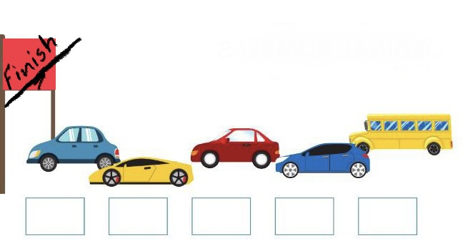
C.b.Complete the following Ordinal Numbers:
fifth
third
__________________________
__________________________
__________________________
second – fourth – sixth- first -seventh
Orthography
A. Fill in with B or P.
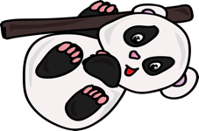 | 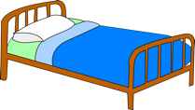 |  | 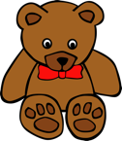
……anda | ……ed | ……en | ….ear
B . Choose (a / a–e / i-e) :
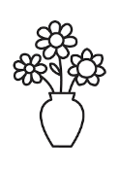  V__s__ |   T_ m _ | 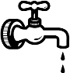  T _ p | 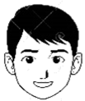  F__c__
(a / a–e / i-e) | (a / a–e / i-e) | (a / a–e / i-e) | (a / a–e / i-e)

C.Write ( cl- pl – bl- ph- dr-tr ) in the suitable blanks:

 | 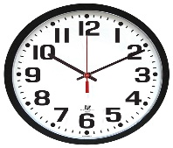 | 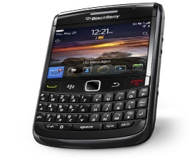 | 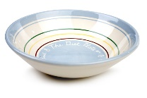
.... uck | .....ock | ..... one | .... ate
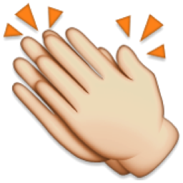 | 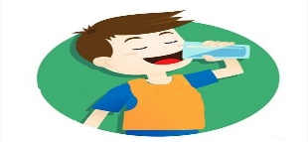 | 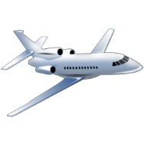 | 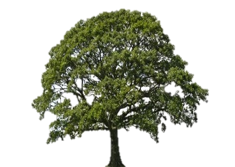
.... ap | ..... ink | .... ane | .....ee

D. Fill in with T or D .

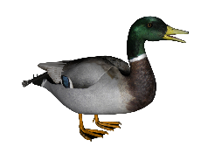 | 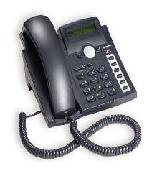 | 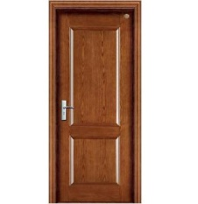 | 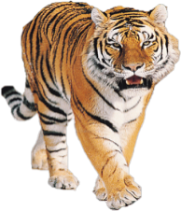 | 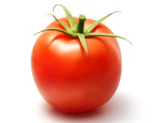 | 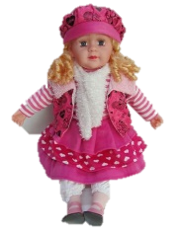
...uck | ...elephone | ...oor | ....iger | ...omato | ...oll

Done by: Zahra Mohammed

