
مدرسة األندلس الخاصة للبنات
العام األكاديمي 2025/2026
نهاية الفصل الدراسي الثاني
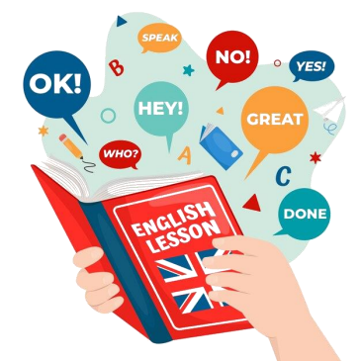اختبار الوحدة التاسعة
مادة اللغة اإلنجليزية
الصف الخامس االبتدائي
اسم الطالبة............................................./ الصف والشعبة ......................................./



نجل _{ي}^{ز} أوراق العمل اإلثرائية مادة اللغة اإل ية
_{ي}مالعام األكادي
2025/2026
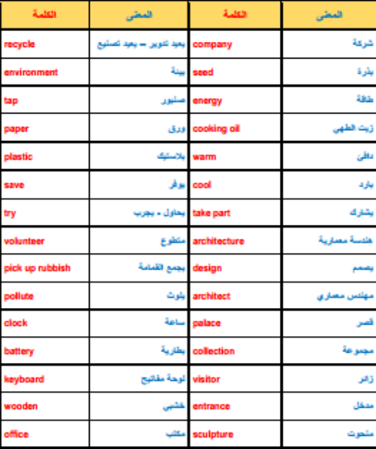الرؤية: تعلم عصري ملهم بهوية وطنية وقيم إسالمية. ¹
نجل _{ي}^{ز} أوراق العمل اإلثرائية مادة اللغة اإل ية
_{ي}مالعام األكادي
2025/2026
Part one: Language Functions
Read and match the questions to their answers.
(A) (B)
1- How can you save energy? a. Drive a car 2- What are you too young to do? b. Turn off the lights. 3- Could you make a poster? c. I promised to clean my room. 4- What did you promise your mom to do? d. Of course I can.
Part two: Vocabulary:
Fill in the gaps with the suitable words from the box.
recycle - paper - energy - company - environment - warm
1) Some factories pollute the _enviromet_________________. We have to stop them. 2) My uncle works for a big ________company__________.
3) We can recaycal all things like ________________paper__, metal, glass, and plastic.
4) Don’t take a jacket with you. It’s __________________and sunny today. 5) Turn off the lights when you don’t need them. We have to save __________________.
الرؤية: تعلم عصري ملهم بهوية وطنية وقيم إسالمية. ²
نجل _{ي}^{ز} أوراق العمل اإلثرائية مادة اللغة اإل ية
_{ي}مالعام األكادي
- Choose the correct word:
1) Mariam would like to __________________ in the cooking competition.
A. take part
B. cook
C. point
D. save
2) My watch stopped working. It may need a new __________________.
A. warm
B. visit
C. tap
D. battery
3) The weather is __________________ in Doha. Let's go outside.
A. office
B. tap
C. cool
D. pollute
4) The sun gives us __________________ to light our homes.
A.money
B. warm
C. energy
D. battery
5) Let's __________________ the rubbish to clean the park.
A. pick up
B. wake up
C. have fun
D. come round
6) It isn't too late to __________________ the environment.
A. save
B. share
C. forgive
D. promise
2025/2026
الرؤية: تعلم عصري ملهم بهوية وطنية وقيم إسالمية. ³
نجل _{ي}^{ز} أوراق العمل اإلثرائية مادة اللغة اإل ية
_{ي}مالعام األكادي
2025/2026
Part three: Grammar:
Choose the correct answer:
1) I would like to __________________ a big house.
A. buy
B. Buys
C. Buying
D. Is buying
2) It’s fun to __________________ to the amusement park.
A. go
B. goes
C. was going
D. were going
3) Nasser is __________________ young to read and write. He’s only one year old.
A. to
B. too
C. two
D. enough
4) I would like to __________________ the environment.
A. protect
B. protects
C. protecting
D. protected
5) Could we __________________ a movie tonight?
A. watch
B. watches
C. watched
D. watching
الرؤية: تعلم عصري ملهم بهوية وطنية وقيم إسالمية. ⁴
نجل _{ي}^{ز} أوراق العمل اإلثرائية مادة اللغة اإل ية
_{ي}مالعام األكادي
Do as shown between brackets.
2025/2026
1. Computers are easy to charges these days. (correct the underlined verb) ________________________________________________________________
2. Could I turning on the air Conditioner? (correct the underlined word) ________________________________________________________________
3. My sister is smart too to win the spelling bee. (correct the underlined word) ________________________________________________________________
4. You are enough pretty; you don’t need makeup. (correct the underlined word) ________________________________________________________________
5. I want to becomes a doctor when I grow up. (correct the underlined word) ________________________________________________________________
6. We decided to buying a new house. (correct the underlined word) ________________________________________________________________
Part Four: Reading Comprehension:
Directions: Read the passage and answer the questions.
(1) We can recycle computers, tablets, mobile phones, and cars. Recycling factories break them into small pieces, and then other factories use these pieces to make new things. This helps reduce waste and saves materials. It is very important to recycle these items because throwing them away is bad for the environment. (2) Batteries and medicine have dangerous chemicals. When we throw them in rubbish bins, they can pollute the soil and water. This can harm plants, animals, and people. (3) Moreover, don’t throw your old sports shoes away! Special factories can recycle them to make sports fields for children around the world.

الرؤية: تعلم عصري ملهم بهوية وطنية وقيم إسالمية. ⁵
نجل _{ي}^{ز} أوراق العمل اإلثرائية مادة اللغة اإل ية
_{ي}مالعام األكادي
2025/2026
1. What is the text MAINLY about?
A. phones
B. recycling
C. factories
D. medicine
2. What does the underlined word (bins) in paragraph (2) mean? A. use
B. dirty
C. plant
D. basket
3. What things can we recycle?
________________________________________________________________
4. Why is it important to recycle?
________________________________________________________________
5. What happens when we throw batteries in the rubbish?
________________________________________________________________
6. What can factories make from old sports shoes?
________________________________________________________________
الرؤية: تعلم عصري ملهم بهوية وطنية وقيم إسالمية. ⁶
نجل _{ي}^{ز} أوراق العمل اإلثرائية مادة اللغة اإل ية
_{ي}مالعام األكادي
2025/2026
Part Five: Writing:
Write a paragraph of six sentences about how can you save the environment around you.
Helping questions:
➢ What should you turn off?
➢ What should you use to come to school?
➢ What should you do with old things?

Content  (Ideas, relevancy &  organization)  2 | Language Use  (Grammar &  Vocab)  2 | Writing conventions |  | Total
Content  (Ideas, relevancy &  organization)  2 | Language Use  (Grammar &  Vocab)  2 | (Spelling)  2 | (Punctuation)  2 | 8

الرؤية: تعلم عصري ملهم بهوية وطنية وقيم إسالمية. ⁷

