# Favorite Color Email.

## Favorite Color: Green

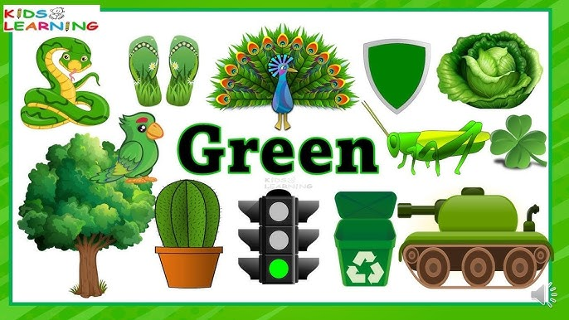

**To: John@gmail.com**

**From:** [**Sara@hotmail.com\**](mailto:Sara@hotmail.com\)

**Subject: My favourite colours**

**Hi John,  
Thanks for your email. Your new room sounds wonderful! I like the blue colour you chose for the walls, but my favourite colour is green.  
  
Green makes me feel calm and relaxed. It reminds me of spring in my country, when the trees are full of fresh green leaves. I enjoy walking in the park and smelling the grass. It feels peaceful and natural.  
  
Green is also the colour of my favourite food—grape leaves. They may be unusual, but I think they are really delicious! I also have a green dress and a green scarf, and I love wearing them in spring.  
  
Please send me pictures of your room when it’s ready.  
Take care,  
Sara**



## Favorite Color: Red

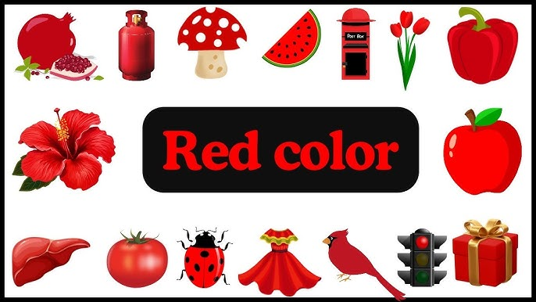

**To: John@gmail.com**

**From:** [**Omar@hotmail.com\**](mailto:Omar@hotmail.com\)

**Subject: My favourite colours**

**Hi John,  
It was nice to hear from you. Your new bedroom must look amazing! I love blue too, but my favourite colour is red.  
  
Red is a strong and bright colour. It makes me feel excited and full of energy. When I see red, I think of the beautiful flowers in summer and the warm fire in winter. Both give me a happy feeling.  
  
Red is also the colour of my favourite food—strawberries. They are sweet and tasty, and I can never get enough of them! I also like my red jacket. It keeps me warm in winter and makes me feel strong.  
  
Don’t forget to send me some photos of your room.  
Best,  
Omar**

## Favorite Color: Yellow

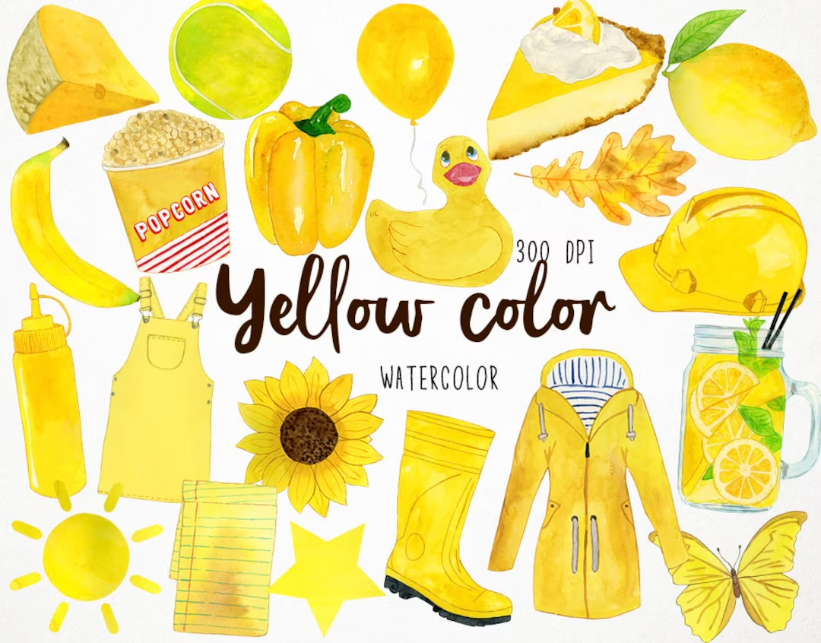

**To: John@gmail.com**

**From:** [**Lina@hotmail.com\**](mailto:Lina@hotmail.com\)

**Subject: My favourite colours**

**Hi John,  
I enjoyed your email. Your new bedroom sounds great! I like blue, but my favourite colour is yellow.  
  
Yellow is a bright and cheerful colour. It always makes me smile. It reminds me of the sun shining in summer and of big sunflowers in my grandmother’s garden. I feel happy whenever I see it.  
  
Yellow is also the color of my favorite corn soup. It’s warm, creamy, and makes me feel good. My yellow T-shirt is also my favourite because it is bright and happy. I will wear it in summer.  
  
Please show me your new room soon.  
Love,  
Lina**

## Favorite Color: Blue

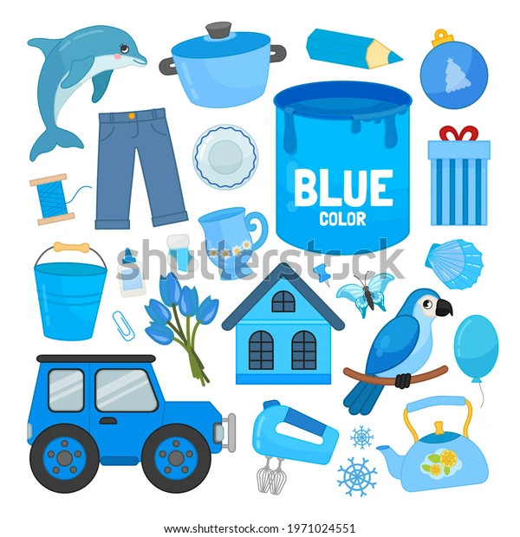

**To: John@gmail.com**

**From:** [**David@hotmail.com\**](mailto:David@hotmail.com\)

**Subject: My favourite colours**

**Hi John,  
Thanks for writing to me. I like your choice of blue walls! My favourite colour is also blue.  
  
Blue makes me feel calm and safe. It reminds me of the sea and the clear sky on a sunny day. Sometimes I just sit outside and watch the blue sky—it makes me peaceful inside.  
  
Blue is also the colour of my favorite food, blueberries. They are small but full of sweet flavour! I also like my blue jeans. They are comfortable and I wear them almost every day.  
  
I’d love to see more pictures of your room when it’s ready.  
Take care,  
David**

## Favorite Color: Purple

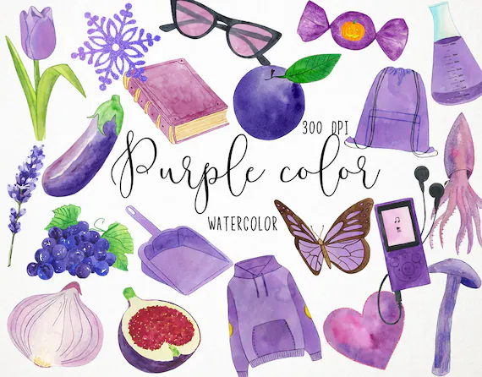

**To: John@gmail.com**

**From:** [**Hana@hotmail.com\**](mailto:Hana@hotmail.com\)

**Subject: My favourite colours**

**Hi John,  
Great to read your email! Your new bedroom sounds very nice. I like the blue walls, but my favourite colour is purple.  
  
Purple is a special and beautiful colour. It makes me feel creative and unique. When I see it, I think of the evening sky and the lavender flowers in the fields. It’s a colour that always makes me dream.  
  
Purple is also the colour of my favourite food—plums. They are sweet and juicy, and I enjoy eating them in summer. I also have a purple sweater that is soft and warm, and I wear it on cool evenings.  
  
Send me photos of your room when you can.  
Best wishes,  
Hana**

**Favorite color: Orange**

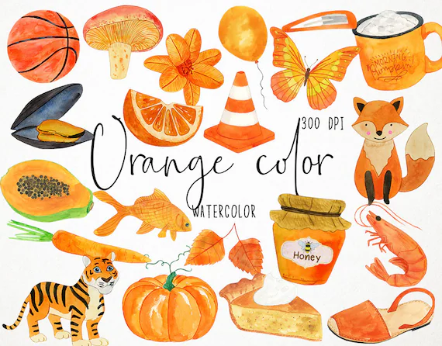

**To: John@gmail.com**

**From:** [**Bob@hotmail.com\**](mailto:Bob@hotmail.com\)

**Subject: My favourite colours**

**Hi John,**

**Thanks for your message. Your new room sounds nice! I like the blue color, but my favorite color is orange.**

**Orange is a warm and bright color. It makes me feel happy and safe. It reminds me of autumn in my country, when the leaves turn dark orange and fall to the ground. It also makes me think of fire in the fireplace during cold nights.**

**Orange is also the color of my favorite food, carrot soup. It may be simple, but it’s the tastiest meal for me! I also love my orange jacket. It is bright and keeps me warm in autumn.**

**I can’t wait to see pictures of your new bedroom.**

**Take care,**

**Bob**