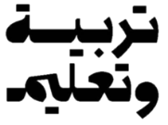

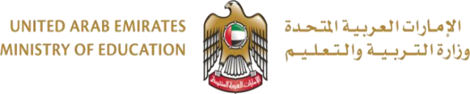
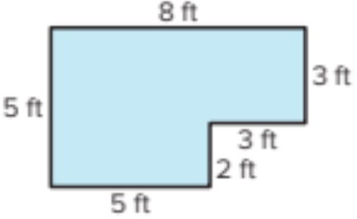
 |  | Student Name
 |  | School
3 |  | Class
Reveal Math |  | Curriculum
General | العام | Stream
Math |  | Subject

Question |  | 9 | اﺴﻟﺆال
Which equation can be used to determine the /2 points
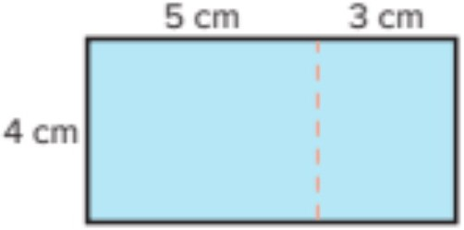
area of the rectangle?
A | ? = 4 + 5 x 4 + 3
B | ? = 4 x 5 |+ 4 x 3
C | ? = 4 + 5 + 4 + 3

الاختبار التجريبي لمادة اﻟﺮﯾﺎﺿﯿﺎت اﻟﻔﺼﻞ اﻟﺪراﺳﻲ اﻟﺜﺎﻧﻲ
Mock Exam Math Term 2

End Of Ǫuestions اﻻﺳﺎﻟﺔ ﺗاﻧﮭت
Question | 10 | اﺴﻟﺆال
Draw one or more lines to partition the figure. /4 points
What is the area of the composite figure?

……………………………………………….

……………………………………………….

……………………………………………….

……………………………………………….

……………………………………………….……………………………………………….

……………………………………………….……………………………………………….

……………………………………………….……………………………………………….

……………………………………………….……………………………………………….

……………………………………………….……………………………………………….

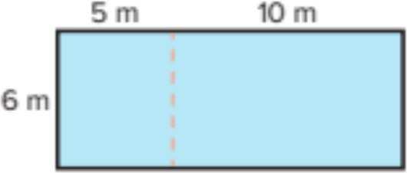
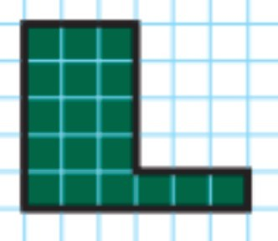
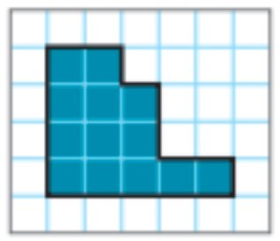
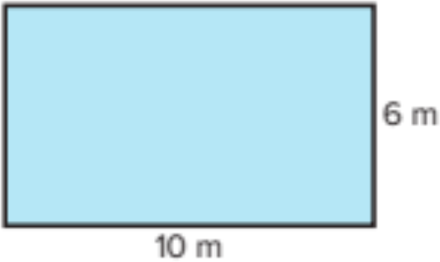
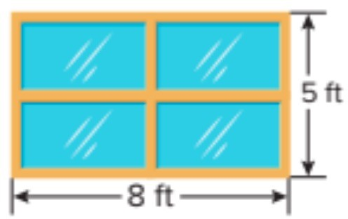
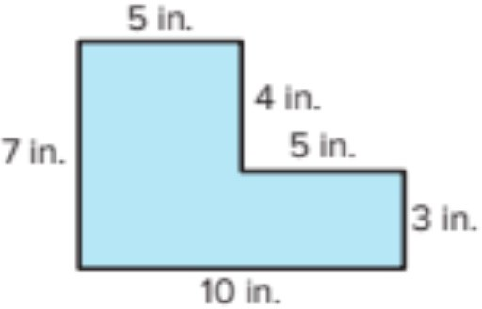
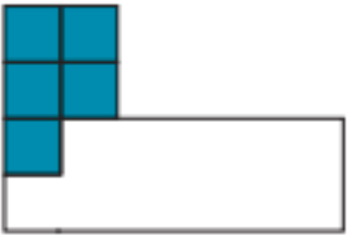
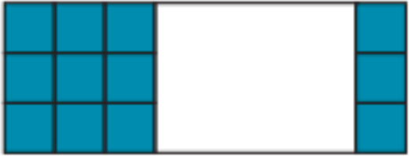
Question |  | 1 | اﺴﻟﺆال
What is the area of the figure? /1 points

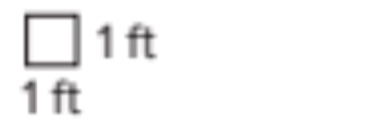
A | 10 square feet
B | 11 square feet
C | 13 square feet
Question |  | 2 | اﺴﻟﺆال
What is the area of the figure? /2 points
A | 16 square meter
B | 32 square meter
C | 60 square meter
Question |  | 3 | اﺴﻟﺆال
What is the area of the composite figure? /2 points
A | 5 square unit
B | 12 square unit
C | 16 square unit
Question |  | 4 | اﺴﻟﺆال
What is the area of the composite figure? /2 points
A | 34 square inch
B | 50 square inch
C | 65 square inch

Question |  | 5 | اﺴﻟﺆال
What is the area of the figure? /2 points
A | 13 square feet
B | 26 square feet
C | 40 square feet
Question |  | 6 | اﺴﻟﺆال
What is the area of the figure? /2 points
A | 12 square unit
B | 24 square unit
C | 27 square unit

Question |  | 7 | اﺴﻟﺆال
What is the area of the figure? /1 points
A | 18 square unit
B | 19 square unit
C | 20 square unit
Question |  | 8 | اﺴﻟﺆال
Which equation can be used to determine the /2 points
area of the rectangle?
A | ? = 6 x 5 + 6 x 10
B | ? = 6 x 5 x 6 x 10
C | ? = 6 + 5 + 6 + 10

