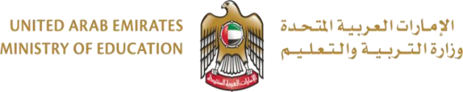

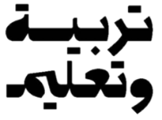

الاختبار التجريبي لمادة اﻟﺮﯾﺎﺿﯿﺎت اﻟﻔﺼﻞ اﻟﺪراﺳﻲ اﻟﺜﺎﻧﻲ
Mock Exam Math Term 2

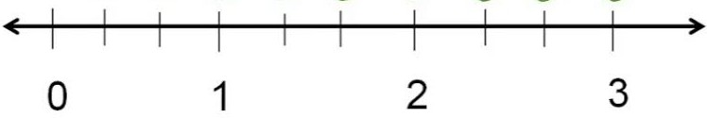
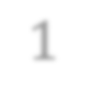
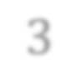
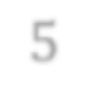
ﻟا اﻟ

Question | 8 | اﺴﻟﺆال
Write the missing fraction on the number line. /4 points

1 5
3 3

 |  | Student Name
 |  | School
3 |  | Class
Reveal Math |  | Curriculum
General | العام | Stream
Math |  | Subject

Question | 9 |  | اﺴﻟﺆال
Circle the fractions that are equal to 1 whole. |  |  |  | /1 points
4 3 3 |  | 7 | 3 | 10
4 4 1 |  | 8 | 3 | 6
Question | 10 |  | اﺴﻟﺆال
Circle the fraction that is less than 1 whole. |  |  |  | /1 points
1 3 3 |  | 8 | 6 | 6
4 4 1 |  | 8 | 4 | 6

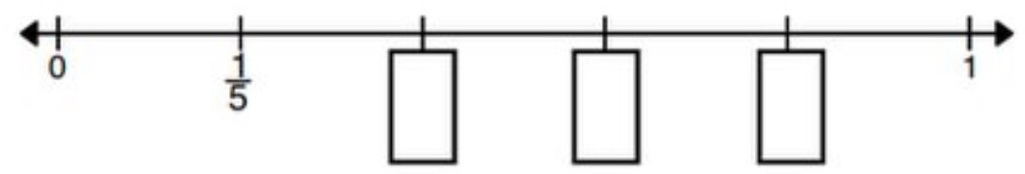
Question | 7 | اﺴﻟﺆال
Write the missing fraction on the number line. /3 points

End Of Ǫuestions

ﺗاﻧﮭت اﻻﺳﺎﻟﺔ

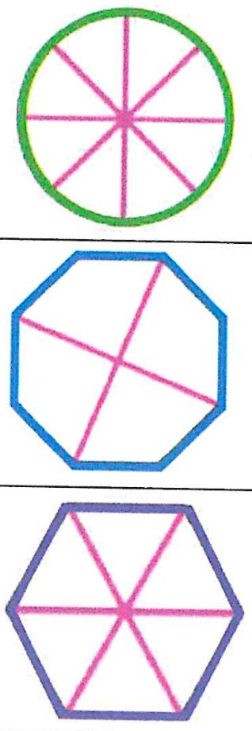
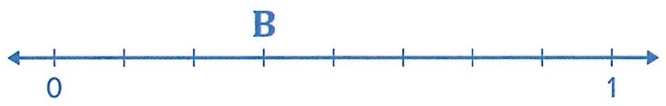
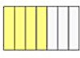
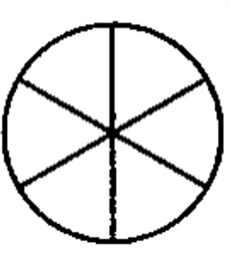

C

B

A
/2 points
Which figure represents one-fourth?
اﺴﻟﺆال
4
Question

C

B

A
/2 points
Which figure represents one-sixth?
اﺴﻟﺆال
5
Question
Question |  | 1 | اﺴﻟﺆال
Which figure represents eighth? /1 points
A
B
C

Question |  | 2 | اﺴﻟﺆال
Which fraction represents the shaded part of the figure? /2 points
A | 3  7
B | 4  7
C | 4  3

Question |  | 6 | اﺴﻟﺆال
Which fraction represents the shaded part of the shape? /2 points
A | 6  6
B | 6  1
C | 0  6

Question |  | 3 | اﺴﻟﺆال
Which fraction is represented by point B? /2 points
A | 5  9
B | 5  10
C | 4  10

