
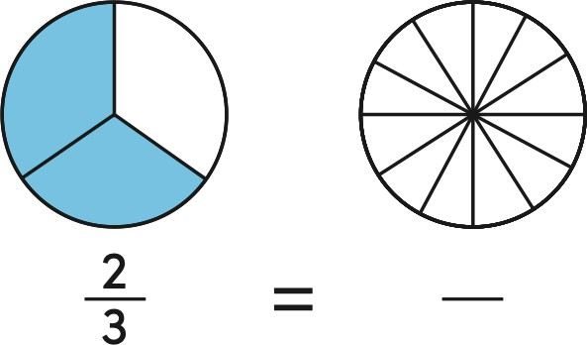
Question |  | 7 | اﺴﻟﺆال
Which equation represents the number lines? /2 points

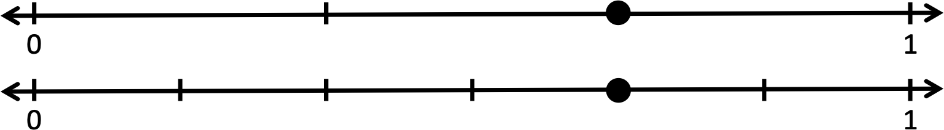

A | 2 4  3 = 6
B | 3 5  3 = 6
C | 4 2  5 = 3
Question |  | 8 | اﺴﻟﺆال
Which number can make the fraction equivalent? /2 points

? 12
A | 2
B | 8
C | 9

 |  | Student Name
 |  | School
3 |  | Class
Reveal Math |  | Curriculum
General |  | Stream
Math | اﺮ | Subject


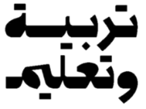

الاختبار التجريبي لمادة اﻟﺮﯾﺎﺿﯿﺎت اﻟﻔﺼﻞ اﻟﺪراﺳﻲ اﻟﺜﺎﻧﻲ
Mock Exam Math Term 2

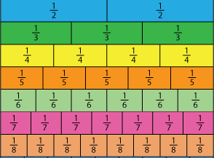
End Of Ǫuestions اﻻﺳﺎﻟﺔ ﺗاﻧﮭت
Question | 9 | اﺴﻟﺆال
Use the number line to complete all the equations. /4 points

2
i. 8 = 4

2
ii. 3 =

6
iii. 8 = 4

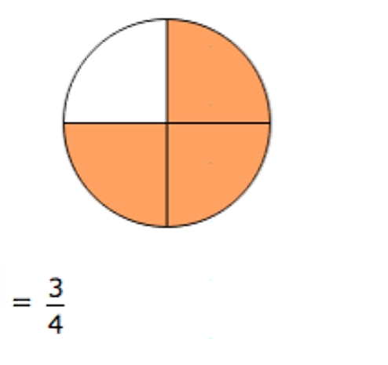
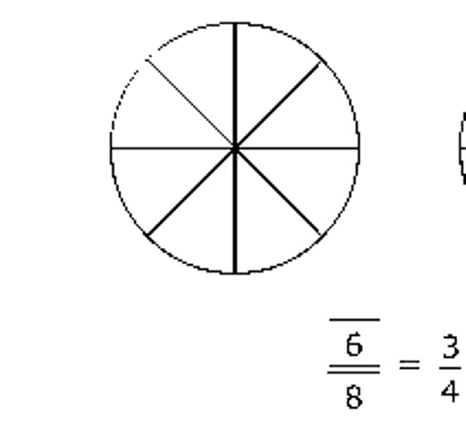
Question |  | 4 | اﺴﻟﺆال
Circle the two models of 𝟏 that represent the same amount? /2 points
𝟐
A | 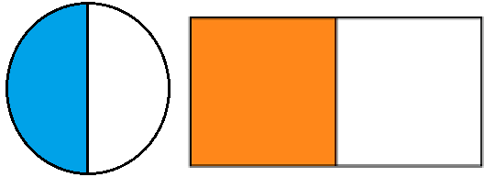
B | 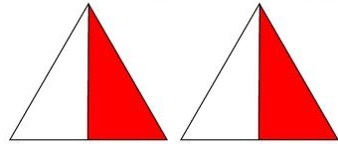
C | 

Question |  | 5 | اﺴﻟﺆال
Which comparison is true? /2 points
A | 3 2  7 > 7
B | 3 2  7 < 7
C | 2 3  7 > 7

Question |  | 2 |  |  | اﺴﻟﺆال
Complete the equivalent fraction sentence. /2 points
 |  |  | ? |  | 3
 |  |  | 8 |  | 4
A | 2
B | 3
C | 4

Question |  | 6 | اﺴﻟﺆال
Use >, <, or = to make the comparison true. /2 points

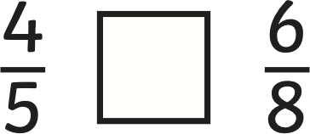

A | >
B | <
C | =

Question |  | 3 | اﺴﻟﺆال
Circle the fraction that are less than 𝟏 /2 points
.
𝟓
A | 1  8
B | 1  4
C | 1  3

Question |  | 1 | اﺴﻟﺆال
Which pair of models present the equivalent fractions? /2 points
A | 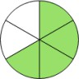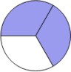
B | 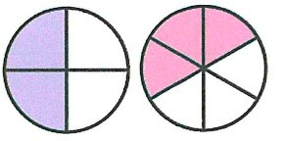
C | 